Combination-Lock using the Max-Chip on the Altera Board

Introduction
After you have now read up on state machines theoretically, it is time to design a real one. To accomplish this we will be using the Max+plusII design software and the MAX-chip on the Altera-board. The Max-chip is an EEPROM (Electronically Erasable Programmable Read-Only Memory), which means that it will not lose a program you stored on it, if it is disconnected from power. It is also infinitely reprogramable.

Methodology

General Design
Let’s take a few minutes now to think about the program we want to write so that it will hopefully work the first time.
What do we want to do? We want to write a state-machine that will take in four numbers and upon the fourth having been entered will go to an ‘open’-state. After any other number is entered, it should return to its default ‘locked’-state.
The state machine itself is of course pure software and we will go later over how to program it. What is however equally important and what we have to deal with beforehand is which inputs and outputs that we need. (It is preferable that you have the Altera Board at this moment in front of you so that you can take a look at it while following the description)

Inputs & Outputs
In regard to inputs we need to be able to enter numbers between 0 and 9, i.e. between 2⁰ and 2^{3,} so we need four switches. (one for 2⁰, one for 2¹, …). For this we will use the little dip-switches in the lower left corner of the board. These can be connected to pins of the Max-chip using some of the wire from your wiring kit.
That is the input side, now to the outputs: we need of course a way to show if our lock is locked or unlocked. Looking to the right of the Max-chip you will see some LEDs, these can be connected to pins of the chip and will display high/low appropriately. One LED would probably already be enough here (light it to show that the lock is unlocked), I would however proposed to you to use two, one that is lit when the lock is locked, one that is lit when the lock is unlocked. This might come in handy with debugging and as you will see, creating another output basically takes no time at all in the Altera Software. Additionally, we should use some of the LEDs to show in which state we are, also very helpful for debugging ☺. Here we have: start-up state, state after first number entered, state after second number entered….. Easy, isn’t it?
Take into account one more thing: the Altera board is clocked at 25MHz. If you just think of entering your number via the dip-switches think again. Any change between two numbers that involves more than one dip-switch will be interpreted by the chip as two separate, incorrect steps, you will return to the start-up state. So, make sure that you can enter your number and only after it has been entered when one of the push-buttons is pressed it should be read. Also take into account that the push-buttons bounce.

State-Machines in VHDL
After this introduction, you are probably now wondering how to write a state-machine in general in VHDL. As this class here is not designed to teach you VHDL. I have included parts of a state-machine VHDL program that I wrote previously at the end of this write-up. It should answer all your basic questions. In case there are any problems left, please go and see the TA.

Working with the Altera Software
We have now covered the basic design steps involved in this lab, so that you can start writing the VHDL code.
When you do so, please take into account that a reset switch should be included (connected to pin 1), which should get you back into the startup state. For this you should use a push button, but please consider when doing this, that the pushbuttons on the board are inverted, i.e. they are high if not pressed and low if pressed. (This is a common design fact with buttons, as it is much easier, to pull them up with a resistor if not pressed, then the other way round)
To start writing go to ‘Applications’ in your ‘Start’ menu and select Max+plus II. Upon starting the program you will probably be asked for a code, these are pinned to the door of the computer room. Go to ‘File’, ‘New’ and select Text Editor File. A new file will appear. Click on ‘assign’, ‘device’ and select as family ‘MAX7000S’ and the EPM7128SLC84-7 as device.
After you have done that and saved your file for the first time (please pay attention to the extension, you need .vhd here), . go to ‘File’, ‘Project’ now and select ‘Set Project to Current File”. When saving your file, also an .acf file will have been created. Open up the file and in the first begin-end block (it should also contain the information about your device) enter your io- terms and the pins you want to assign to them.

Here an excerpt to show the syntax.
BEGIN
|PB1_DEBOUNCED_SYNC_OUT : PIN = 46;
|PB1_OUT : PIN = 50;
|SLOW_CLOCK_OUT : PIN = 49;
|PB1_SINGLE_PULSE : PIN = 48;
DEVICE = EPM7128SLC84-7;
END;

(This is just a small example) You also have to pay attention to the fact that a lot of the pins on the chip are already pre-assigned, e.g. for connections to the JTAG-programming header, or for Vcc and Ground. (Check your Altera University Package User Guide)
To make sure that you are not accidentially assigning an output to any one of these pins, after compiling your project, check the *.rpt file that will be created.
In case your program is displaying the right output when simulating, but not when running on the chip, please ask your TA to take a look at the pin locations you are usein.

Should any of the pins have two terms assigned to them, you have to change your pin-assignments. (This is why we assign the pins manually. Automatic assignment sometimes unluckily causes double assignments)

R R R R R R R R R
E E E E E E E E E
S S S S S S S V S S L
E E E E E E E C R C E E S V L L L
R R R R R R R C E L R R B C S S S
V V V V G V V V I G S G O G V V _ C B B B
E E E E N E E E N N E N C N E E d I _ _ _
D D D D D D D D T D T D K D D D p O g e f
-----------------------------------------------------------------_
/ 11 10 9 8 7 6 5 4 3 2 1 84 83 82 81 80 79 78 77 76 75 |
RESERVED | 12 74 | LSB_d
VCCIO | 13 73 | LSB_c
#TDI | 14 72 | GND
RESERVED | 15 71 | #TDO
RESERVED | 16 70 | LSB_b
RESERVED | 17 69 | LSB_a
RESERVED | 18 68 | MSB_dp
GND | 19 67 | MSB_g
RESERVED | 20 66 | VCCIO
RESERVED | 21 65 | MSB_f
RESERVED | 22 EPM7128SLC84-7 64 | MSB_e
#TMS | 23 63 | MSB_d
RESERVED | 24 62 | #TCK
RESERVED | 25 61 | MSB_c
VCCIO | 26 60 | MSB_b
RESERVED | 27 59 | GND
RESERVED | 28 58 | MSB_a
RESERVED | 29 57 | RESERVED
RESERVED | 30 56 | RESERVED
RESERVED | 31 55 | RESERVED
GND | 32 54 | RESERVED
|_ 33 34 35 36 37 38 39 40 41 42 43 44 45 46 47 48 49 50 51 52 53 _| Pin
Figure 1. Pin Assignment table in *.rpt-file
This is an example of the chip-pin picture that is included in the *.rpt file. Please pay attention here to the fact that pin2 is not GND as shown in the Altera Documentation, pin 4 is GND. It is advisable, that you always use pin 4 to connect ground to in case you are working with the Logic analyzer.

Simulation
Now your program is compiled, to make sure that it does what you want it to do, you need to simulate it. (And you need the simulation to get checked off)
To do this, you must have compiled your VHDL-file, and you must have the project set to it. If you go to the ‘File’-menu, select ‘new’ and then the ‘.scf’ extension, a new waveform file will be created for you.
Make sure that you select appropriate values for the end time in the ‘file’-menu and for the grid size in the ‘options’-menu. Now go to ‘Enter Nodes from SNF’ in the ‘nodes’ menu. After you applied the ‘list’ command all nodes in your file should be shown and you can select these that you want displayed in your simulation file.
Press ‘OK’ to continue.
Now you should be in the default setup of the simulator file.
The next thing is to create a meaningful waveform. Highlighting the node, you can use one of the buttons on the right-hand side of the screen to change the entire waveform to 1,0, clock etc.
You can however also highlight a channel go to ‘Utilities’ -> ‘Selection’ and select a certain time interval that is to be changed. That way you can e.g. simulate pressing the pushbutton for a certain time.
Here is a sample simulation.
Figure 2. Sample Simulation Waveform file
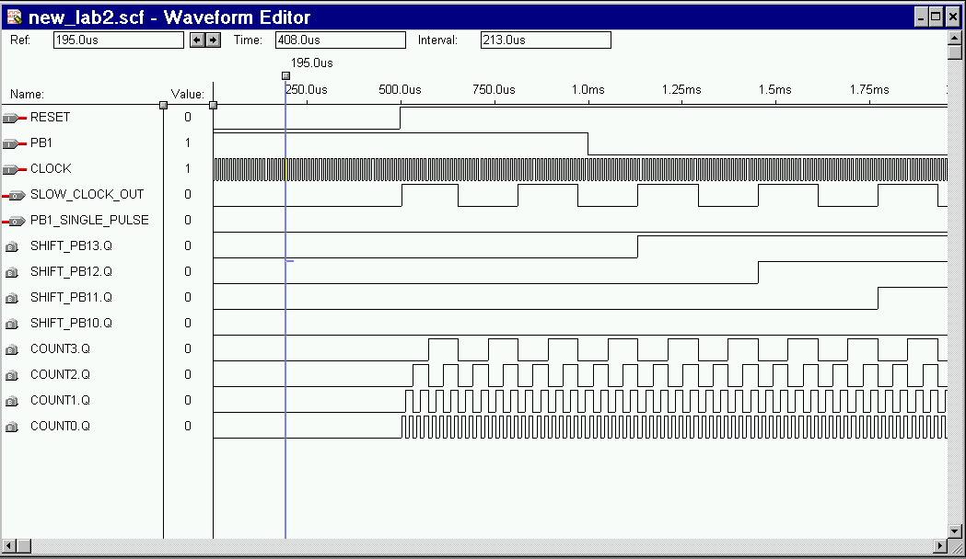

Programming the Max-Chip
When programming, be sure that you are programming the right chip on the board. You select these through the on-board jumpers. Take a look in the Altera User Guide for the correct configuration. Also, check ‘Hardware Setup’ in the ‘Options’ menu to make sure that you are writing to LPT2 as that is the port you will be connecting your byteblaster to.
You are now ready to program. Connect your Altera-board with the byteblaster cable that should be included in the box to LPT2 and hook up the power supply.
To program the chip, go to the ‘Max+plus II’ menu and select the programmer. Check the output that appears on the screen especially the device. If everything is okay, press program.
Entering the correct combination should now cause your chip to display the proper output.

