Debouncing buttons using the Max-Chip on the Altera Board

Introduction
Pushing a button seems to be one of the easiest jobs you can ever be asked to do. However, designing a button so that your push will be read as what you intended it to be: a single push does take some problem-solving skills in regard to hardware- and software design.

Several problems pop up here:
- Pushing the button will basically make it swing, it will bounce between ‘off’ and ‘on’ for about 80ms.

Figure 1. A button is pressed shortly after t=0, the button will then go high, will however bounce back to 0 a few times

- The Altera board which we are using for a number of exercises in this lab is clocked at 25MHz. This means that for you to push the button only once, you would only be allowed to press it for 0.00000004s, which is impossible. Thus, we have to make sure that no matter how long we hold the button, only one impulse will be transmitted to the system.

The techniques to overcome these problems will now be demonstrated using the Altera Board and a VHDL program that will be written by you. After debouncing the switch, we will count its highs and the highs of the undebounced input out to the LEDs so that you can compare the two.
Note: this lab must be done on the new Minitower machines, only they have the appropriate software-guards installed.

Methodology

Synchronizing the switches
First, we have to synchronize the switch, by tying it to a clock impulse.
If you would want to do this hardware wise, the easiest solution would be to send the input from the button through a D-Flip-Flop. Why? Because a D-Flip-Flop is edge-triggered, which means that no matter when you press the button changes will only occur on the next clock low-clock high transition for a positive edge-triggered or on the next clock low-clock high transition for a negative-edge triggered D-Flip-Flop.

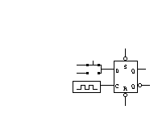
Figure 2. Button tied to positive edge-triggered D-Flip-Flop that is connected to the clock)

As we will however be working with the Altera Board, we have to program the D-Flip-Flop in VHDL. The code to simulate edge-triggering is (clock’event). Should you desire to simulate a positive edge-triggered Flip-Flop, your code would be for example:
If (clock’event) and (clock = ‘1’)

Debouncing
Debouncing takes place, by sending the data from the switch to a shift-register into which we read the input of the switch. At first the shift-register will be filled with ‘0’s and ‘1’s, because of the bouncing. However, with the switch settling in its high-state, the shift-register will fill with ‘1’s and we can assume then that the switch has been really pressed. To declare a register with four cells in VHDL use:
Register_Name: std_logic_vector (3 downto 0)

To fill this register you might use for example:
Register_Name(3) <= PB1_IN

It doesn’t make sense though to fill the register at a sampling rate of 25MHz, because then a single bounce (up or down) may fill the entire register. This would lead to incorrect results.

Slowing the clock
So, how do you slow your clock down now and how much do you have to slow it down? A sensible sampling speed here is 50Hz, which implies a clock period of 20ms. It would thus take 80ms - which is also the bouncing time - to fill the register. Thus we should be filling the register fast enough that the delay in execution of the button pressing will not be noticeable however, we are sampling slow enough to avoid any erroneous decisions due to bouncing.
The easiest way to achieve the desired delay in clock speed is again to create a register. Fill it with a one every time the system clock ticks. When the register is now completely filled with ones, make your slow clock tick once.

Filling the register is very easy.
You should initialize the register to all ‘0’s:
Register_Name = “0000”

If your command line is now:
Register_Name = Register_Name +1

, then your register will be “0001” after the first run, “0010” after the second run, “0011” after the third run, etc.
This explanation should also make it easy for you to see how long your register must be to get the appropriate delay.

Single pulsing
After this has been done, we also have to make sure that our system does not mistakenly read one push of the button as several pushes because the button was pressed for longer than one system time interval.
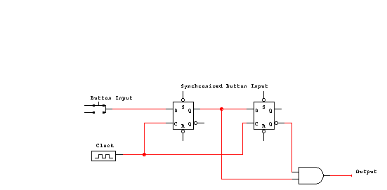
To achieve this single-pulsing hardware wise, we would add another D-Flip-Flop and an And-Gate to the D-Flip-Flop we already used previously.
Figure 3. Synchronizing and Single-Pulsing Circuit

Button Input

Clock

Synchronized Button

Delayed Button

Output

Figure 4. Waveforms for Symchronizing and Single-Pulsing Circuit

As you see, we send the synchronized button input to a second D-Flip-Flop and ‘AND’ it with the negated output of that Flip-Flop(which is shown here as positive and negative edge-triggered). The negated output of the second Flip-Flop is referred to as delayed here.
The reasoning behind this combination is that the output of the second flip-flop should be delayed by one clock pulse in regard to that of the first flip-flop. Thus for exactly one clock period (in this example a half clock period) both inputs to the AND-gate will be high, giving us a high output.
To code this circuit in VHDL now, basically the only thing you need to do is to check for your synchronized input and delayed input first, then set the delayed input to the inverse of the synchronized input. Due to the high clock-speed with which we are working and the edge-triggering, this is enough delay to get a high output for one clock period.

Outputting the undebounced and debounced Highs to the seven-segment Displays
The easiest way to count the highs on the 7-segment Displays is to create two registers of length 4. These registers can at max. express 16 different numbers, this is also the max. amount of numbers that can be expressed on a single 7-Segment-Display when using the Hex number system. Counting the frequency of highs will take an appropriate if-statement and the same code like above:

Register = Register + 1

The next thing that needs to be done is that you define the content of a register of length seven, that stands for the seven segments of the Display, based on the four-bit register.
After this has been done, take a look in the Altera user guide to find out which output pins are connected to which segment and assign appropriate output terms to them.

Working with the Altera Software
We have now covered the basic design steps involved in this lab, so that you should be able to come up with a basic layout of the program and can start writing the VHDL code.
When you do so, please take into account that a reset switch should be included. You should also consider, that the pushbuttons on the board are inverted, i.e. they are high if not pressed and low if pressed. (This is a common design fact with buttons, as it is much easier, to pull them up with a resistor if not pressed, then the other way round)
When starting to write the program go to the ‘assign’ menu, ‘device’ and select as family ‘MAX7000S’ and the EPM7128SLC84-7 as device.
After you have done that and saved your file for the first time, an .acf file will have been created. Open up the file and in the first begin-end block (it should also contain the information about your device) enter your io- terms and the pins you want to assign to them.

Here an excerpt to show the syntax.
BEGIN
|PB1_DEBOUNCED_SYNC_OUT : PIN = 46;
|PB1_OUT : PIN = 50;
|SLOW_CLOCK_OUT : PIN = 49;
|PB1_SINGLE_PULSE : PIN = 48;
DEVICE = EPM7128SLC84-7;
END;

Please take into account that these are not all the io-terms you will need. This is just a small example. You also have to pay attention to the fact that a lot of the pins on the chip are already pre-assigned, e.g. for connections to the JTAG-programming header, or for Vcc and Ground. (Check your Altera University Package User Guide)
To make sure that you are not accidentially assigning an output to any one of these pins, after compiling your project, check the *.rpt file that will be created.
Should any of the pins have two terms assigned to them, you have to change your pin-assignments. (This is also why we assign the pins manually. When we assign them automatically, sometimes unluckily double assignments occur that might cause problems)

R R R R R R R R R
E E E E E E E E E
S S S S S S S V S S L
E E E E E E E C R C E E S V L L L
R R R R R R R C E L R R B C S S S
V V V V G V V V I G S G O G V V _ C B B B
E E E E N E E E N N E N C N E E d I _ _ _
D D D D D D D D T D T D K D D D p O g e f
-----------------------------------------------------------------_
/ 11 10 9 8 7 6 5 4 3 2 1 84 83 82 81 80 79 78 77 76 75 |
RESERVED | 12 74 | LSB_d
VCCIO | 13 73 | LSB_c
#TDI | 14 72 | GND
RESERVED | 15 71 | #TDO
RESERVED | 16 70 | LSB_b
RESERVED | 17 69 | LSB_a
RESERVED | 18 68 | MSB_dp
GND | 19 67 | MSB_g
RESERVED | 20 66 | VCCIO
RESERVED | 21 65 | MSB_f
RESERVED | 22 EPM7128SLC84-7 64 | MSB_e
#TMS | 23 63 | MSB_d
RESERVED | 24 62 | #TCK
RESERVED | 25 61 | MSB_c
VCCIO | 26 60 | MSB_b
RESERVED | 27 59 | GND
RESERVED | 28 58 | MSB_a
RESERVED | 29 57 | RESERVED
RESERVED | 30 56 | RESERVED
RESERVED | 31 55 | RESERVED
GND | 32 54 | RESERVED
|_ 33 34 35 36 37 38 39 40 41 42 43 44 45 46 47 48 49 50 51 52 53 _| Pin
Figure 5. Pin Assignment table in *.rpt-file
This is an example of the chip-pin picture that is included in the *.rpt file. Please pay attention here to the fact that pin2 is not GND as shown in the Altera Documentation, pin 4 is GND. It is adviseable, that you always use pin 4 to connect ground to in case you are working with the Logic analyzer.

Simulation
Now your program is compiled, to make sure that it does what you want it to do, you need to simulate it. (And you need the simulation to get checked off)
To do this, you must have compiled your VHDL-file, and you must have the project set to it. If you go to the ‘File’-menu, select ‘new’ and then the ‘.scf’ extension, a new waveform file will be created for you.
Make sure that you select appropriate values for the end time in the ‘file’-menu and for the grid size in the ‘options’-menu. Now go to ‘Enter Nodes from SNF’ in the ‘nodes’ menu. After you applied the ‘list’ command all io nodes in your file should be shown and you can select these that you want displayed in your simulation file.
Press ‘OK’ to continue.
Now you should be in the default setup of the simulator file.
The next thing is to create a meaningful waveform. Highlighting the node, you can use one of the buttons on the right-hand side of the screen to change the entire waveform to 1,0, clock etc.
You can however also highlight a channel go to ‘Utilities’ -> Selection and select a certain time interval that is to be changed. That way you can e.g. simulate pressing the pushbutton for a certain time.
Here is a sample simulation, please don’t take this as a literal example. There are other inputs/outputs that might be important to you.
Figure 6. Sample Simulation Waveform file
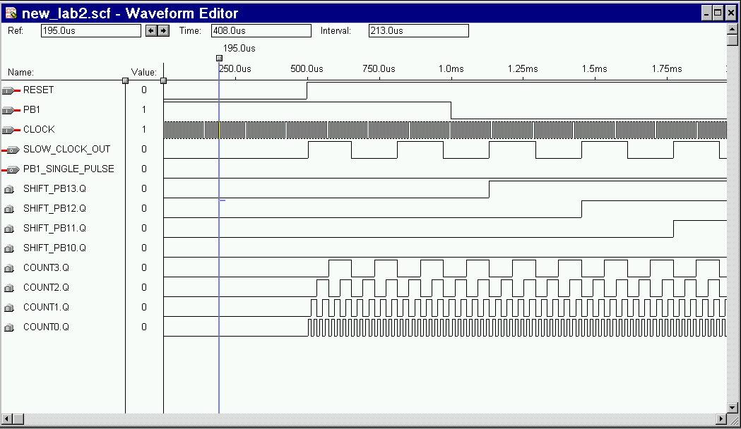
To simplify the simulation you might want to cut down temporarily on the size of the register that you use for slowing down the clock, as the real one might take up too much simulation time.

Programming the Max-Chip
When programming, be sure that you are programming the right chip on the board. You select these through the on-board jumpers. Take a look in the Altera User Guide for the correct configuration. Also, check ‘Hardware Setup’ in the ‘Options’ menu to make sure that you are writing to LPT2.
You are now ready to program. Connect your Altera-board with the byteblaster cable that should be included in the box to LPT2 and hook up the power supply. The MAX-chip is an EEPROM, which means it is erasable and programmable however, it will keep its programming until you reprogram it, so you can conviniently program it in the computer room and then take it outside to connect it to one of the Logic Analyzers.
To program the chip, go to the ‘Max+plus II’ menu and select the programmer. Check the output that appears on the screen especially the device. If everything is okay, press program.

Examining the output with the Logic Analyzer
Now connect the board to the logic analyzer (and to the power supply). Connect the leads of the logic analyzer and connect them to the out-terms that you consider relevant. Also connect the input and reset to the appropriate input pins.
Going to the logic analyzer systems menu, you should pay attention to the thresholds and to the sampling frequency. Additionally you might also think about setting a trigger. (For those of you who don’t know what this means: when in the trigger menu to which you get from the ‘System’-window, you can set an event from which on the logic analyzer will count the sampling interval. This event should in our case logically be that the switch is pressed)
In the Setup screen, you can select the probes that you have connected to the chip, then go ‘Window’ and to ‘New’ to open a waveform window, as this should make it easier for you to see what is going on. Should too many probes be displayed, you delete the unnecessary ones by clicking on them and then pressing delete. Missing ones can be added by clicking on the left-most button of the screen.
After this has been done, start the sampling by clicking on the ‘Run’-button in the upper right part of the screen.
Your waveform output will look similar then to:
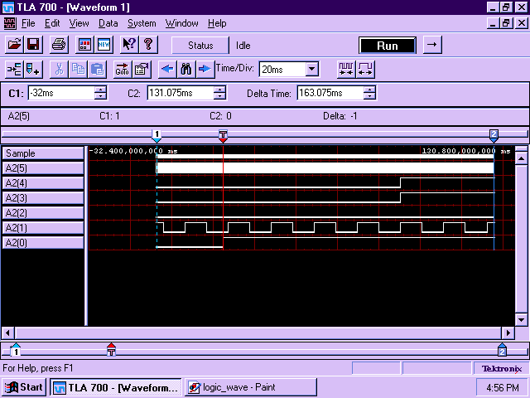
Figure 7. Sample Waveform Window

