Note: One of the other sections is talking about something different and doing this lab later – so I would recommend waiting until this is cleared up after break.

ECE 2036 Lab #3 mbed thermostat
Lab Deadline: ???

I. Introduction
Embedded devices account for 98% of the world’s microprocessors. For every desktop computer, there are over 100 embedded devices. A high-end car can contain up to 100 microprocessors. Embedded devices contain a computer with software that is typically not changed by the user (called Firmware). Most users are not aware that their cellphones, cameras, audio players, and TVs contain a computer with firmware. C/C++ is currently the most widely used language for embedded devices. ARM processors similar to the one found in the mbed module are used in about 80% of embedded devices including most cellphones.

1. Real-Time Systems
Many embedded devices are also real time systems. A real-time system needs to read in data from external sensors, perform computations based on new sensor data, and update the control outputs within a fixed period of time.

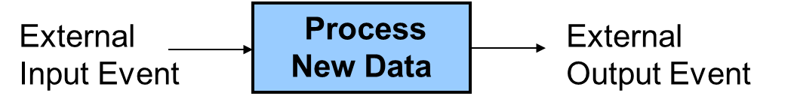

A Real-Time System reads in sensor data, processes the data, and updates control outputs
Examples in cars include airbags, antilock brakes, and engine controls. Autopilots in airplanes and spacecraft are another example. In many of these systems, responding too slowly will cause system failure. Most real-time systems need a response time on the order of milliseconds or even microseconds.
2. The New Nest Thermostat
Programmable home heating and cooling thermostats are also embedded devices. Thermostats could perhaps also be considered a real-time system, but with a response in range of minutes that is several orders of magnitude slower than most applications. The new Nest thermostat seen on the next page was designed by an engineer that previously designed Apple’s iPods. It uses a color LCD similar to those in cellphones and a rotating ring for user input. Menus are used to change settings and display data. This device is now available at your neighborhood Lowes, the Apple Store, and Amazon. Nest Labs is one of Silicon Valley’s newest startup success stories. It is an interesting example of how even common household devices are currently being re-engineered using new technology.
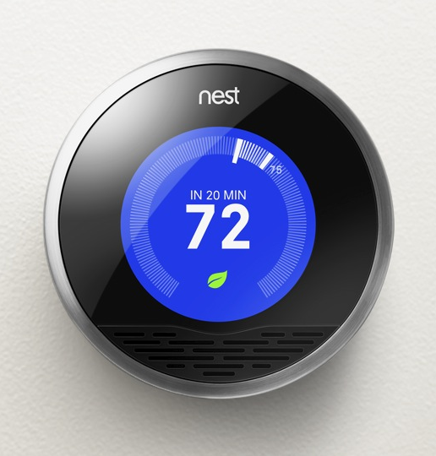
The Nest Thermostat
As seen in the printed circuit board (PCB) image below, the nest contains an ARM Cortex A8 32-bit processor, temperature, light, motion, and humidity sensors and Wi Fi. The motion sensor senses when no one is home to save energy. A learning algorithm monitors your inputs to setup automatic scheduling. Wi Fi can be used for remote control via the web and for automatic firmware updates.
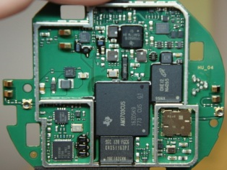
Hardware found in the Nest
Most home heating systems use 24V AC relays to turn the fan, heater, and cooling on and off. A driver circuit (http://mbed.org/users/4180_1/notebook/relays1/) converts a digital logic output signal from the processor to the higher voltage and current levels required to trigger the relays.
II. Building a Thermostat Using Mbed
For this assignment, we will use the ARM processor on the mbed module and develop C/C++ code to build a basic thermostat. Mbed’s I/O devices all have been setup with easy to use C++ Application Programming Interface (API) calls that are described in the mbed handbook (http://mbed.org/handbook/Homepage). The API code provided with mbed uses C++ classes and methods to make them easier to use. These are similar to a simple device driver and it is not necessary to understand the hardware details of each I/O device to develop complex C/C++ applications on mbed. Follow the hyperlinks provided in this document for additional documentation and C/C++ code examples.
A TMP36 analog temperature sensor (http://mbed.org/users/4180_1/notebook/lm61-analog-temperature-sensor/) will be used to read the temperature. Using mbed’s built-in analog to digital convertor and a C/C++ I/O Application Programming Interface (API) call, the voltage from the sensor will be converted from analog to a floating point value returned in a C/C++ variable. This temperature value is then checked to determine when to turn on and off the heating and cooling systems. Two of mbed’s built in LEDs will be used to indicate the value of the output signals that control the heating (LED4) and cooling (LED3). It will not be attached to an actual HVAC system or require a driver circuit to control the relays.
Thermostats and control systems must use hysteresis to avoid rapidly switching on and off. Mechanical systems take time to respond and wear out faster if they are constantly turned on and off. They need to run for a longer period of time to avoid excessive mechanical wear. They are also more energy efficient with longer run times. In the case of a thermostat for a heater, with hysteresis the heater would turn on at the temperature control point, but then not turn off until the temperature has increased a couple degrees. It would not turn back on until the temperature drops a couple degrees. This requires state information (i.e. heater is on or off) and then checking a different temperature threshold when turning the device on versus turning it off. The figure below shows a simple state transition diagram for a thermostat set at 75º. The plus and minus 1 degree provide the hysteresis to give an average temperature of 75º. It should start in the state where the heater is off.
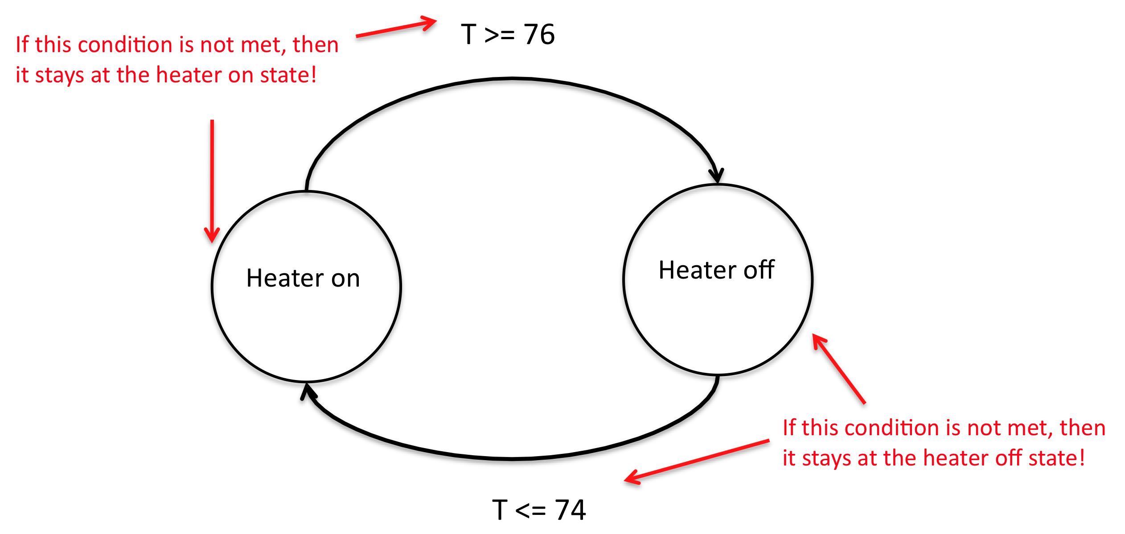
State Diagram for a Basic Thermostat set to 75
1. Modeling a State Machine in C/C++
Nested control structures are required to implement a complex state machine in software. As an example, a simple state machine is shown below in C/C++ that blinks an LED. When the program runs, LED1 changes every .33 seconds.
include "mbed.h"
DigitalOut myled(LED1);

enum Statetype { LED_off = 0, LED_on };

int main()
{
Statetype state = LED_off;
while(1)
{
switch (state)
{
case LED_off:
// calculate the Moore-Type Outputs
myled = 0;
// calculate the next state
state = LED_on;
break;
case LED_on:
// calculate the Moore-Type Outputs
myled = 1;
// calculate the next state
state = LED_off;
break;
}
wait(0.33);
}
}

A simple state machine in C/C++ that blinks an LED

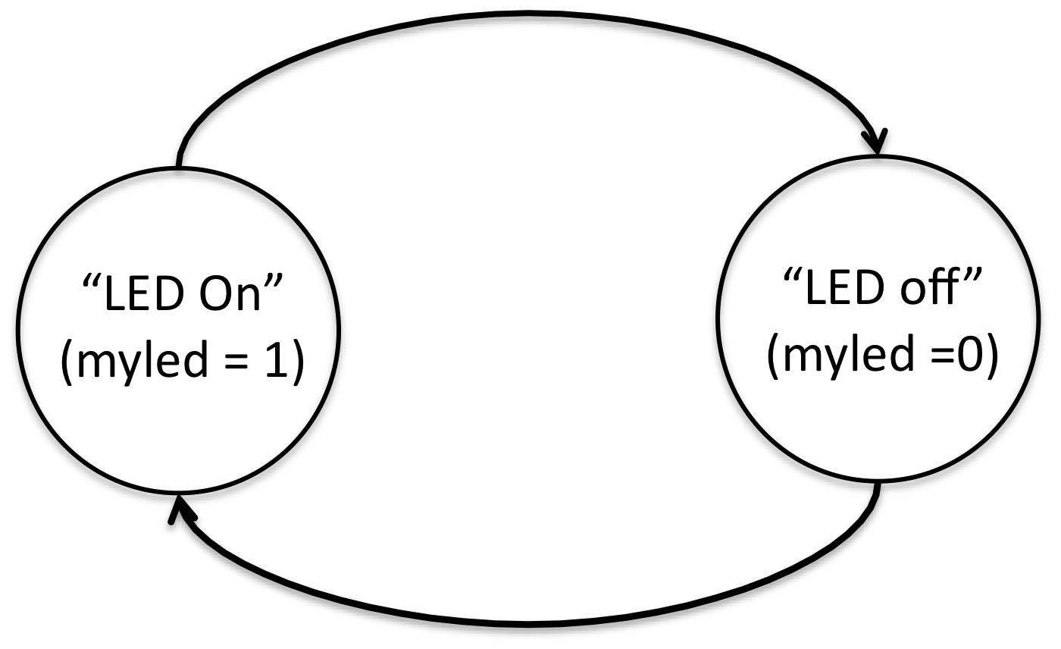
A simple state diagram for state machine in above C code

An infinite while loop containing a switch() statement helps structure the code. The switch() statement selects one of several cases based on the current state. Each case (i.e., state) then checks the appropriate conditions to assign the next state. An enumerated type is used for state. Use this overall structure in your code for the thermostat’s state machine. It will be more structured, readable, and easier to understand. For just two unconditional states, an if..else statement could be used, but with a case statement adding more states and input conditions will be easier as the state machine gets more complex. A default case could be added to jump to the initial state just in case it ever entered an undefined state. Wait() actually slows down the state machine clock to around three clocks per second. Without the wait() the LED would change so fast it would only look a bit dimmer. Note that this simple state machine does not check inputs. For a more complex state machine with inputs, inside each case an if..else statement could be used to check inputs to determine the next state. Each transition arrow leaving a state corresponds to one if statement.

2. Reading the Temperature Sensor

An TMP36 wiki page is provided that shows how to connect the TMP36 sensor and read the temperature using C/C++ on the mbed module. Be careful it looks just like the 2N3904 transistor in the kit, so check the tiny marks on the case’s flat area for the part number. Start by wiring up the TMP36 sensor to mbed and getting the demo code at the wiki page to work as shown. Use the compiler import code link (i.e., box after source code) on the TMP36 wiki page to copy over the complete project demo files for the TMP36. This will verify your hardware connections and sensor operation before trying your new code.
See the breadboard theory wiki, if you have not used a breadboard before and be very careful whenever inserting or removing the mbed module, as the pins can easily bend and break. If that happens, you will need a new mbed module. It is a good idea to put the mbed on your breadboard once and leave it there. A larger version of the TMP36 breadboard setup photograph is also available using the link under the image on the TMP36 wiki page. Device placement is often a critical first step in building a circuit on a breadboard and also in designing a printed circuit board (i.e. shorter wires with less wires crossing). . Typically placing devices with a large number of connections close together simplifies everything As mentioned in previous assignments, I would recommend the arrangement of all your components in this lab at the following YouTube site (http://www.youtube.com/watch?v=oozKIHzeoQU).
Looking ahead at the hardware needed for this laboratory assignment and consulting the mbed pin layout (colored card in kit), the LCD needs a number of GPIO (General Purpose Input/Output) connections. Since the SD card and Shiftbrite RGB LED need an SPI (Serial Peripheral Interface) interface, it probably makes sense to put the LCD on the right side of the mbed using GPIO pins on the right side of the mbed module. The SD card and Shiftbrite could go on the left nearer the SPI pins. The TMP36 can use any AnalogIn pin, Pushbuttons can use any GPIO pin, and the speaker will need a PWM pin or the analog output pin, but these devices need only one pin and are not as critical. Pins are passed as arguments when the pin I/O functions are initially setup, so as long as the pin supports the hardware function needed they can be moved around with a one line change in your C/C++ code. Details on pin assignment suggestions can be found in the Skeleton code provided for use with this assignment. Instructions on downloading this code are provided later near the end of this document. Check the card with pin functions first before moving pins. Using a pin for a non-supported hardware function does not cause a compile error; it generates a run time error which flashes the LEDs once the code runs. Be sure to setup the breadboard bus power strips. There is only one open pin on mbed for gnd and 3.3V (Vout) and power will be needed for several devices. Double check power pin connections before inserting the USB cable for power, if they are incorrect that is the easiest way to destroy an IC.
If you did NOT do Assignment #2 or #3, you will need to follow the instructions provided in your mbed box to setup a user account for access to the C/C++ compiler and space to save source files. You have to logon to use the compiler, but not the wiki pages.
The temperature sensor outputs a voltage that indicates the current temperature. An analog-to-digital converter inside the processor converts the analog voltage input to a 12-bit integer value at a maximum sample rate of 200Khz. The mbed C++ API AnalogIN reads a 3.3V max analog input and scales it to a float value between 0 and 1.0 (i.e., a 1.0 would be 3.3V and 0 would be 0V). DigitalOut can be used to control the LEDs. Use LED4 to indicate the state of the heater (i.e., LED4 on means the heater is on).
The mbed I/O APIs use C/C++ classes to enable users to work at a higher level of abstraction without dealing with the low-level hardware details. The API is basically a set of useful C functions and classes, just like any additional functions or classes you may write yourself. As example, here is what happens automatically when you use the AnalogIn API C++ class to read an analog input pin:
- The pin is configured for analog input on initial use of AnalogIn. Most I/O pins can have one of several different functions that are controlled by registers. I/O registers on RISC processors are in memory addresses in a special range reserved just for I/O devices . Pins are a critical resource on an IC, so most I/O pins are configurable on new ICs. A pin can cost as much as 100K transistors inside the chip.
- Whenever the AnalogIn variable is read, the eight input analog multiplexor is set to select the correct analog channel to read the pin. This requires writing a value to another I/O control register along with a small delay for the analog voltage to stabilize.
- The A/D convertor is then started by writing a start A/D conversion bit in the A/D control register.
- The software then waits in a while loop for the A/D to report back that the conversion is complete. The hardware sets a bit in an A/D status register when this happens. The A/D can only read 200K samples per second. This is a lot slower than instruction execution times, so code needs to wait for the A/D conversion complete bit.
- The AnalogIn value is then read in from the A/D data register, scaled from 0.0 to 1.0, and returned as the float value of the AnalogIn variable.

A lot of development time is saved by using AnalogIn, there is no need to find and understand all of these hardware details in the LPC1768 User’s Manual to get the I/O device to work. This is why I/O device drivers are typically used in larger systems.
Since temperature changes slowly, it is engineering overkill to check the temperature as fast as possible in a tight while loop. In an actual system, running slower can save power or provide extra CPU time for other tasks. On mbed, a time delay can be added using wait(). Check the temperature sensor and update states no more than three times a second.
With the temperature sensor connected and the program running, you can simulate the effect of the heater turned on by lightly pushing down on the sensor with your finger (being careful not to knock it loose from the protoboard). Your finger is typically a bit cooler than your core body temperature and it does not cover the entire sensor, but you should be able to warm the sensor up to the high 80s after a few seconds. So you can test the thermostat by setting the control point a bit higher than room temperature so that the heat comes on (LED3). Then by warming it up a couple degrees with your finger you should see the heat turn off after a couple seconds. Monitor the temperature using your LCD display that you got working in Assignment 2&3 while this is happening. It is also possible to cool down the sensor using an ice cube in a small plastic bag (be careful not to get water on the breadboard or sensor leads). Spraying the sensor with an aerosol can of “dust-off” cleaner can even be used to cool the sensor below freezing.
3. Skeleton Project Code to Get Started
Several steps are need to add all of the libraries and *.h files to a project and the required includes in main.cpp for all of the I/O devices that will be used. To save you time on the assignment, a sample project with all of these already added and the simple state machine code example that just blinks an LED has been provided for your use. The skeleton code project setup is available at:
http://mbed.org/users/4180_1/code/mymbedthermostat/
It is not required to use the skeleton code, but it will likely save you some time finding all of the *.h files and adding them one at a time. To use the skeleton code, plug in your mbed, logon to mbed.org, open a new tab in the browser window and go to the URL above. On the web page that appears click the Import this program box (upper right). It will open a compiler window and import all of the files into your project area and setup a new copy of the project.
It also has some sample I/O code just to show that things are setup OK for all of the new I/O devices. It should compile without errors after import (a warning or two is OK), but if you run it you will get a runtime error on SD file I/O (i.e., all four mbed LEDs will flash) until you delete the SD card I/O example code or attach the SD card breakout and insert and SD card. You will not use the SD card for this lab so you will not need this part of the code for this lab; however, you will use this in future labs. You will also see an error message on the PC if you have a terminal application program running hooked up to the virtual com port. Once that code is deleted, if you recompile and download the state machine will blink the LED.
You will still need to read the handout and wiki pages to figure out how to hookup the hardware and what needs to be done to finish the program to fill in the missing code in main.cpp. The code has pin assignments for the devices based on the earlier breadboard suggestions, but feel free to change them. Shiftbrite.h does not have all of the class code filled in, you will need to edit that file and add it for the final part of the project. If you see some handy code on wiki pages or in the compiler and want to cut and paste it into your compiler source code, highlight it with the mouse, use “control C” to copy, move to the paste location, and use “control V” to paste. The format button in the compiler is also helpful to clean up nested control structures and auto indent.
4. Laboratory Requirements
Basic Heater Thermostat (40%)
Implement the basic heating thermostat as described in Section 2. This should have two states, HEAT_OFF and HEAT_ON. Have the set-point hardcoded to 75. Your program must implement a Moore state machine. The state transitions are determined by the temperature sensor and set-point values. The fixed output in each state is the output of LED3, which simulates the heater being on or off. You may choose to implement only this “basic thermostat” for a maximum of 75% on the lab, or implement the “improved thermostat” for a maximum of 100%. The first step in implementing this lab should be to get your system working with the basic thermostat, LCD, and pushbuttons. The second step should be to add the speaker, data-logging, and RGB LED to your system. The third and final step should be to implement the “improved thermostat”, which consists of modifying your state machine and adding a pushbutton callback. Note: You will lose points if you do not implement a Moore-type state machine as described in Section II. Your main() function should consist of an infinite while loop that contains one switch statement, with one case for each state (2 states for basic thermostat, 5 states for improved thermostat).
Add LCD display (5%)
In assignment #2 you should have successfully gotten your display to work. Now you need to use the LCD to provide useful output to the user, by displaying temperature and thermostatic status information. Display the current temperature (in two digits) and current mode on line 1. You must display all temperature values in Fahrenheit. You may alternatively choose to add some user input mechanism to toggle between F and C modes (i.e., a fourth pushbutton or simultaneous pressing of two pushbuttons). Line 2 of the LCD should display the thermostat’s current state and the current temperature set-point, depending on the current mode.
The LCD must be used to receive any credit for this lab. The 5% is to grade the quality of your LCD output. Since you only have 16 characters of space on each LCD line to work with, you must carefully design your LCD output to display all necessary information. Your LCD output should be identical (or very similar) to the following:
---------------- ----------------
|Temp=XX F Heat| |Temp=XX F Heat|
|Heating to XX | |Holding above XX|
---------------- ----------------
(HEAT_ON state) (HEAT_OFF state)

The LCD can be updated using the same rate as the state machine (i.e. one time at the end of the while loop, just before wait() is called). Note that when you print “Heating to XX”, you may want to add three spaces at the end (“Heating to %2d “) to clear any residual LCD ouput.
Add User Input (10%)
Use two pushbuttons to change the temperature set-point. One pushbutton should increase the set-point by one degree each time it is pressed. The other pushbutton should decrease the set-point by one degree each time it is pressed. If you did not implement pushbuttons in Assignment 3, read the pushbutton wiki page and watch the videos for additional help using pushbuttons with mbed.
You should use the PinDetect class to implement pushbuttons. The pushbutton callback option probably makes the most sense for this problem and the last example on the pushbutton wiki page shows two callbacks for two pushbuttons. The usage of the global variable count is similar to that of the set-point in your program. In addition to incrementing or decrementing a set-point, your pushbutton callbacks should also use the LCD functions locate() and printf() to display the modified set-point on the LCD. You can re-print the entire 2nd line by locating to (0,1) before calling printf(). A better approach would be to locate to a specific column in line 2 and use printf() to re-print only the set-point, as shown below:
myLCD.locate(???, 1); // Move cursor to column ??? on line 2
myLCD.printf(“%2d”, heat_setpoint); // Print the heat setpoint

The cursor location (???) depends on the current state, and should be stored as a global variable (such as setpoint_cursor). In HEAT_OFF or COOL_OFF, the LCD should display “Holding above XX” or “Holding below XX”, and in these cases setpoint_cursor has the value 14. In HEAT_ON or COOL_ON, the LCD should display “Heating to XX” or “Cooling to XX”, and in these cases setpoint_cursor has the value 11. Thus you should set the value of setpoint_cursor in your state machine, just as you set the values of the LED variables.
Improved Thermostat with Heating and Cooling (25%)
Build a thermostat that controls either heating or cooling, depending on the mode set by the user. This thermostat has five states: OFF, HEAT_OFF, HEAT_ON, COOL_OFF, and COOL_ON and two different temperature thresholds (i.e., heat_setpoint and cool_setpoint). The OFF state is the default state upon reset, indicating that the thermostat is powered off. The HEAT_OFF state indicates that the thermostat is powered on, but heating is not turned on because the room temperature is above the heat set-point. The COOL_OFF state indicates that the thermostat is powered on, but cooling is not turned on because the room temperature is below the cool set-point.
Add a third pushbutton to be used as the “mode button”. Upon reset, the mode is set to OFF. Pressing the mode button once should chance the mode to HEAT. Pressing the mode button again should change the mode to COOL. Pressing the mode button again should change the mode back to OFF. Thus, you will a third global variable (i.e., mode) whose value is changed by the user via a pushbutton interrupt. The mode variable should be an integer with three possible values: 0 (OFF), 1 (HEAT), or 2 (COOL). (A good programmer might make a “Modetype” enumeration for mode values similar to the “Statetype” enumeration for state values.) A concise way to have an integer variable (mode) cycle through the values 0, 1, and 2 is as follows:
mode = (mode + 1) % 3; // Cycle forward by 1
This method of cycling through a list of values is very useful in many programming situations. If there were four modes to cycle through (0 through 3), you would simply use modulo 4 instead of modulo 3.
Thus, you will have three global variables (heat_setpoint, cool_setpoint, and mode) which act as control variables for your system. The temperature sensor provides a fourth control variable that determines the behavior of your state machine. Your program implements a Moore state machine, in which each state has a fixed set of outputs (the LEDs in this lab). In each state, you look at one or more of the control variables to determine the state transition. For example, in the OFF state, the value of the mode variable determines the transition (if mode == HEAT, go to HEAT_OFF, if mode == COOL, go to COOL_OFF, if mode == OFF, remain in OFF). The HEAT_OFF state can transition back to OFF (depending on mode) or it can transition to HEAT_ON (depending on the temperature sensor and heat_setpoint values). The HEAT_ON state can either stay put or transition to HEAT_OFF (depending on the temperature sensor and heat_setpoint values). The logic for COOL_OFF and COOL_ON is similar to the logic for HEAT_OFF and HEAT_ON.
To determine the outputs in each state, use the following rules. LED3 should be on or off to simulate heating being on or off. LED4 should be on or off to simulate cooling being on or off. LED1 and LED2 should indicate the current mode of the system. LED1 off and LED2 off indicates that the thermostat is powered off. LED1 on and LED2 off indicates that the thermostat is in heat mode. LED1 off and LED2 on indicates that the thermostat is in cool mode.
The LCD output displays for each of three additional states are shown below:
---------------- ---------------- ----------------
|Temp=XX F Cool| |Temp=XX F Cool| |Temp=XX F off |
|Cooling to XX | |Holding below XX| | |
---------------- ---------------- ----------------
(COOL_ON state) (COOL_OFF state) (OFF state)
Add Speaker, for Pushbutton and State Feedback (10%)
For user feedback, use the driver transistor and speaker to make a fast click sound whenever a pushbutton is pressed to increment or decrement the set-point. Also make a short beep when the mode is changed, heating turns on or off, or cooling turns on or off. The PWM speaker PlayNote() function is probably the best choice for this program. You should have used this in Assignment 3. Three different beep tones should be played to distinguish between mode changes, heat turning on or off, and cooling turning on or off.
In general, interrupt routines (i.e. callback functions) need to be fast, so it would not be a good idea to call PlayNote() within an interrupt routine if you were playing a long note. One option to avoid this is to have a global flag variable that is set in the interrupt routine (to trigger an action) and then serviced in the main loop (perform the action and clear the flag). For this lab, it is acceptable to play the fast click sounds from within the pushbutton callbacks. The longer beep tones can be played in the main loop. A good location for these PlayNote() calls is the same conditional statements that you use to determine state transitions. See the speaker wiki page for additional hardware and software help using speakers with mbed.
Add RGB LED State Display (10%)
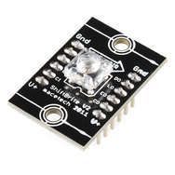
Use a shiftbrite to add a color display of the current state like the Nest ( i.e., off, heat-orange, cool-blue). For this portion, a new C++ class must be developed for a single shiftbrite and placed in a separate *.h file. It should function similar to the existing mbed APIs, it will call the SPI class (and Digital Out) but extend it for a shiftbrite. See the shiftbrite wiki page for additional help using shiftbrites with mbed and the mbed “making it a class” example. Reading the code in the classes developed in the speaker wiki page examples will also provide some more details. So in the main program, it would work something like this after an #include “Shiftbrite.h”:
// declare a new Shiftbrite connected to these pins using a class
Shiftbrite myShiftbrite(penable, platch, pred, pgreen, pblue);
…
// call the class member function to set the LED color
myShiftbrite.write(red, green, blue);

After studying the links with the example class code described earlier, for the new Shiftbrite class here is an additional hint. You will need a constructor and a member function (write) to write a new color to the Shiftbrite. The SPI API has three required pin arguments (one is not used but still needed) and the other examples only have one. So here is a line showing how three would work in the class constructor:

Shiftbrite::Shiftbrite(PinName pin_e, PinName pin_l, PinName pin_do,
PinName pin_di, PinName pin_clk): _pin_e(pin_e), _pin_l(pin_l), _spi(pin_do, pin_di, pin_clk)
{
//setup SPI options and initialize digital outs
}

With these also in the class definition:
private:
//class sets up the 4 pins
DigitalOut _pin_e;
DigitalOut _pin_l;
SPI _spi;
};

When hooking up the Shiftbrite, the pins on the left side (see lettering on PCB) must be used. The pins on the right side go through a logic buffer so that you can connect long chains of Shiftbrites. Notice that if it is ever plugged into the breadboard upside down, the power pins get reversed, and if the supply does not shutdown from high current the chip burns out!
The Shiftbrite and the Speaker draw a bit more current from the power supply than the other devices. A power surge can cause a momentary voltage drop on the supply and this might cause a low temperature reading the instant that they turn on at a state change. If this is a problem, the TA has some 10uf capacitors that can be connected across the sensor’s power supply pins (right at the sensor pins). The longer lead on the electrolytic capacitor goes to the + supply pin. A small time delay (<1sec?) might also help after turning them on, if the problem persists.
ECE 2036 Lab 3 Check-Off Sheet

Student Name: _________________________________________________
Professor: _____________________________________________________

Demonstration | TA Signoff
Basic Thermostat (40%)
Add LCD (5%)
Add Pushbuttons (10%)
Improved Thermostat (25%)
Add Speaker (10%)
Add RGB LED (10%)
Late Penalty (-20% per day)
Demo Late Penalty (-10 % per day)

Lab Submission Instructions:
Each lab must be demonstrated to the TA and submitted on T-Square on or before the due date and time. Students should be finished with the lab before the start of TA office hours on the due date, so that they may get the lab checked-off on the due date and then submit the final code on T-Square. Of course, students may get checked-off and submit their code early! Students cannot expect to get TA help on lab due dates, as their time will be dedicated to lab check-offs. Only one formal check-off attempt is allowed per student, and the entire lab must be checked-off at once.
If you cannot demo the lab in office hours on or before the due date and time, you must come demo during one of the next two TA office hour days after submitting your code online. There will be a 20% per day penalty if the lab is not submitted on T-Square on time. There will be an additional 10% per day per day penalty if you do not demonstrated to the TA within two TA office our days of submitting online.

