ECE 2036A First Programming Assignment
Due dates: Section B: Monday, September 8
Section C: Wednesday, September 10
Demo and Explain Program to 2036 TAs during lab hours

TA checkoff _____________________________ Score:_____________________

A key feature of C++ is the ability to create classes, which are central to object-oriented programming (OOP). In this lab, you will create a single object in software that represents a simple adding machine that is, at a high level, generally similar to the basic mechanical calculator created by Blaise Pascal in 1642, which is called the Pascaline (see figure below)

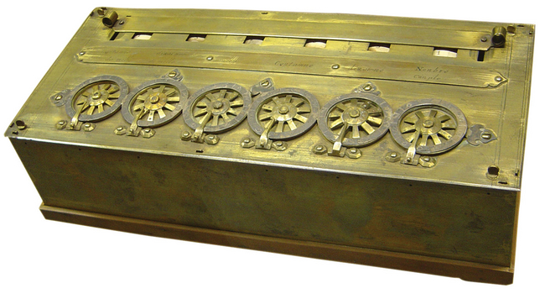

For this first lab, you will need to help create the class Pascaline. Although this is not exactly how the Pascaline operated, for your Pascaline object you will need three private integer data members, register1, register2, and registerResult. Also you will need the following member functions for your object, which are setRegister1( int ), setRegister2 (int), setRegisterResult(int), getRegister1(), getRegister 2(), getRegisterResult(), addRegisters(), clearRegisters(), getInputValues(), and displayOutputValue().

About 30 years later, Leibnitz added a mechanical multiply feature called a “Leibnitz Wheel”. Add a multiplyRegisters() member function to the class and an integer data member, productResult to make this improvement. Get and set functions will also be needed for the new productResult data member. DisplayOutputValue() should display both the sum and product.

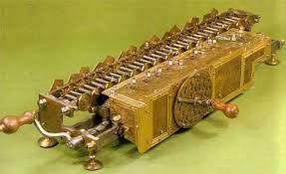
A hard copy of skeleton code for this lab is provided to you during class time to help you get started. As a part of this lab, it is your responsibility to manually type in this skeleton code! Do NOT get a softcopy from another source! You will include the implementation of the member functions OUTSIDE the class definition; however, in this lab your entire program will be in one text file, which you should call pascaline.cc. As explained in section 3.6 of the textbook, we will start to separate files in a more sophisticated way to include a class interface in a header file with a separate implementation file for class member functions.

Programming Requirements – Must be done in your source code the TA will check for it!
1. Create a member function, clearRegisters(), that sets register1, register2, registerResult, and productResult to zero. This function has no values passed to it and has a void return type.

2. Create a constructor that initializes the data members of the Pascaline object to zero.

3. Create a member function, addRegisters(), which will add the value of the two registers, register1 and register2, and set the registerResult to the appropriate value. This function has no values passed to it and has a void return type.

4. Create a member function, productRegisters(), which will multiply the value of the two registers, register1 and register2, and set the productRegister to the appropriate value. This function has no values passed to it and has a void return type. Note: These features are not in the template code provided and will need to be added in the appropriate places.

5. You will need to create the member function, getInputValues(), which should prompt the user for the inputs in the following way:

Please input the contents of register 1:
Please input the contents of register 2:

This function has no values passed to it and has a void return type.
6. You will need to create the member function, displayOutputValues(), which displays the results of the calculation in the following way. This output example below assumes that the contents of register1 is 3 and the contents of register2 is 4. This function has no values passed to it and has a void return type. It also puts an extra newline at the end – see sample output that follows on the next page.

***Pascaline Result: 3 + 4 = 7
***Leibnitz Wheel Result: 3 * 4 = 12

6. There are seven places marked in the code that you must insert a missing line or correct an intentionally placed syntax error. These places are marked by a comment before the error or missing line as:

//Missing line
or
//Correct syntax error

Sample Sessions

Please input the value of register 1: 5
Please input the value of register 2: 6
***Pascaline Result: 5 + 6 = 11
***Leibnitz Wheel Result: 5 * 6 = 30

Please input the value of register 1: -10
Please input the value of register 2: 8
***Pascaline Result: -10 + 8 = -2
***Leibnitz Wheel Result: -10 * 8 = -80

Please input the value of register 1: -9
Please input the value of register 2: -8
***Pascaline Result: -9 + -8 = -17
***Leibnitz Wheel Result: -9 * -8 = 72

Please input the value of register 1: 22
Please input the value of register 2: -12
***Pascaline Result: 22 + -12 = 10
***Leibnitz Wheel Result: 22 * -12 = -264

Here is a simple C++ example showing the basic include setup needed for Visual Studio:

// iodemo.cpp : Defines the entry point for the console application.
// A simple I/O demo for visual studio - note includes and using setup
// this include below is only needed on the Microsoft VS C/C++ compiler
#include "stdafx.h"
// include iostream to use cin and cout
#include <iostream>
// saves typing of std::cout and std::cin
using std::cout;
using std::cin;
using std::endl;

int main()
{
//declare variables
int i=0;
//infinite loop - ctl C exits during input
while(1) {
//read input
cout << "input an integer? ";
cin >> i;
//add 1
i++;
//print result & goto new line
cout << i << endl;
}
return 0;
}

On different C/C++ compilers, the include setup may be slightly different. The project must initially be setup in Visual Studio using File-> New project -> Visual C++ -> Win32 -> Win32 console application (i.e., characters only - no complex GUI windows) when creating a new project in Visual Studio. Build -> Build Solution compiles it and once it “succeeds” (see final output line in lower output window), use Debug -> Start without Debugging to run it. The program output appears in a B/W text only command window that pops up once the program runs. The window disappears when the program ends in some versions of Visual studio and some versions say “type any character” to close the new window. Visual studio is already installed in the ECE PC clusters.

