6Score:______ Section:____________ Date:__________ Name:______________________________

ECE 2036 Laboratory Assignment 6

Due Date: Section A - April 23, B – April 24

Final day for all TA in lab demos is April 24!
A thread is just a sequence of code ready to execute. In C++, this can be thought of as just a special function to run in parallel with the main program. Only programs with multiple threads can run code faster using multiple processor cores working in parallel. The default C++ program runs on only one processor core even on multicore processors. Unfortunately, threading ideas and multicore processors are newer than C++. This means that they are not supported in the standard C++ language features. Some newer languages such as C# and Java have such support. There are however, OS API calls that enable C++ to support multiple threads. Since they are OS specific, such code only runs on one OS and compiler. This lab will use Windows and Visual Studio. Students with MACs can run a Windows partition on their MAC or use the Klaus lab PCs. Thread programs could be converted to run on MACs by changing these special APIs to the ones for a MAC and/or other compilers, but it would take several extra hours of work for this lab. Linux also has a special C++ thread library called Pthreads with similar APIs. Pthreads can run on several common OSes, but a special library may need to be installed or linked.
In this lab, you will use C/C++ and the Windows OS to compare the performance of a program with and without threads. The program computes the Mandelbrot set. Read http://warp.povusers.org/Mandelbrot/ for background and an explanation of the C++ code used for the fractal computations. Two versions will be timed and compared. One will use a standard application without any thread creation. The second version will use four created threads each computing the color for different pixels. The main application will also need to wait for all of the threads to complete using an OS synchronization primitive called a semaphore and read a timer to determine execution time. Be sure to use the same algorithm on both the threaded and non-threaded version so that the timing and multicore speedup comparison (i.e. threads vs. no threads) makes more sense.
On processors with multiple cores, such as the newest PCs in the ECE Klaus PC labs that have two cores you should be able to demonstrate close to a linear speedup, since this CPU bound problem has the ideal properties needed. So you could see close to a 2X speedup on a dual core processor using two threads. It can be split up evenly among processors, does very minimal I/O, and only has minimal shared data. The processor cores do share the same memory. The point here is to balance the computational load for maximum speedup. Be sure to shutdown other applications when taking timing measurements other applications running and even the cache will impact timing. The OS is always running other tasks and threads, so timing can vary quite a bit each time it runs. If you have access to a four core processor, you could see a speedup of almost 4X. With an i7 processor with 8 threads you should see some additional speedup beyond 4 due to hyperthreading (two different threads can run on one core on the i7 and reduce pipeline stalls). There are even some new processors used in high-end servers with 16 cores.
A very similar example program that searches for perfect numbers is attached along with additional information on the various synchronization APIs available in the Windows OS. The example program shows how to create threads, time execution, and use semaphores. A source code file is for the example available at http://users.ece.gatech.edu/~hamblen/3055/course/perfect.cpp or you could cut and paste the code that follows. In VS create a “WIN32 Console Application” when creating the project, so that printf can be used in a basic text or console window (i.e., no complex GUI is needed). If you have or move to a newer version of VS you may need to convert the project files to the new version, but the C code will be the same. This example uses semaphores, in the lab assignment you can also use semaphores. A summary of the other OS synchronization primitives in Windows is provided on the last page of this assignment for those who are interested. Some of these other synchronization primitives are a bit faster, but a semaphore is perhaps the most powerful one.
Here is a C example with and without threads that searches for Perfect numbers. According to the ancient Greeks, a perfect number is an integer equal to the sum of its integer divisors with no remainders. 6 for example is evenly divisible by 3,2, and 1, and 1+2+3=6.
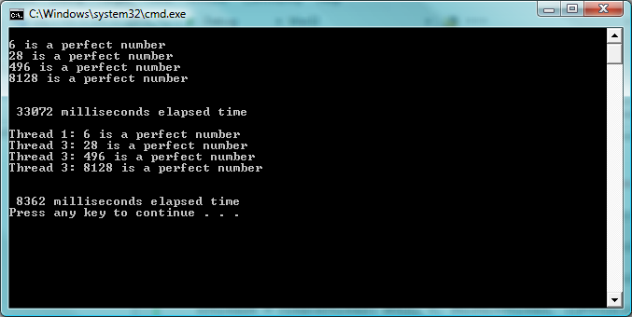
Timed results above are from one thread version and then four threads searching for perfect numbers. Note that a near linear speedup of nearly 4X is obtained using four threads on a four core processor.
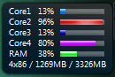
Here is a display of how busy the cores are in Windows on a Quad core processor. Without threads, only one core is totally busy cranking through numbers. Some other OS tasks appear to be running some of the time on the other cores.
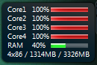
When running four threads, all cores are busy on a Quad Core Processor.
The code for this example follows. It shows how to create and start running threads using CreateThread and synchronize them using the Windows OS APIs and semaphore synchronization primitives. The GetTickCount API reads a millisecond timer and this value used to compute the code execution time. Sleep(x) delays x milliseconds.
// Perfect.cpp : Defines the entry point for the console application.
#include "stdafx.h"
#include "Windows.h"
#include "LIMITS.h"
static HANDLE Thread_semaphore;
int _tmain(int argc, _TCHAR* argv[])
{
HANDLE hThread1;
DWORD dwThread1ID = 0;
HANDLE hThread2;
DWORD dwThread2ID = 0;
HANDLE hThread3;
DWORD dwThread3ID = 0;
HANDLE hThread4;
DWORD dwThread4ID = 0;
INT nParameter = 1;
DWORD WINAPI PerfectThread (LPVOID lpArg);
DWORD time_count;
unsigned long i, j, sum;
printf("\n");
time_count = GetTickCount();
// count primes using only one thread
for (j=2; j<=100000; j++)
{
sum = 0;
for (i=1; i<j; i++)
{
if ((j % i) == 0) sum = sum + i;
}
if (sum == j) printf("%d is a perfect number\n", j);
}
time_count = GetTickCount() - time_count;
printf("\n\n %d milliseconds elapsed time\n\n\r", time_count);
// now do it with four threads
// setup a semaphore for synchronization of threads with an initial value of 0 (waits on 0)
Thread_semaphore = CreateSemaphore(NULL, 0, 4, TEXT("Thread_Done"));
time_count = GetTickCount();
hThread1 = CreateThread( NULL, 0, PerfectThread, (LPVOID)nParameter, 0, &dwThread1ID);
nParameter++;
hThread2 = CreateThread( NULL, 0, PerfectThread, (LPVOID)nParameter, 0, &dwThread2ID);
nParameter++;
hThread3 = CreateThread( NULL, 0, PerfectThread, (LPVOID)nParameter, 0, &dwThread3ID);
nParameter++;
hThread4 = CreateThread( NULL, 0, PerfectThread, (LPVOID)nParameter, 0, &dwThread4ID);
// waits for all four threads to signal done with release semaphore
WaitForSingleObject(Thread_semaphore, INFINITE);
WaitForSingleObject(Thread_semaphore, INFINITE);
WaitForSingleObject(Thread_semaphore, INFINITE);
WaitForSingleObject(Thread_semaphore, INFINITE);
time_count = GetTickCount() - time_count;
printf("\n\n %d milliseconds elapsed time\n\r", time_count);
CloseHandle(hThread1);
CloseHandle(hThread2);
CloseHandle(hThread3);
CloseHandle(hThread4);
return 0;
}
// code for each of the threads to execute
DWORD WINAPI PerfectThread (LPVOID lpArg) {
INT threadnumber = (INT) lpArg;
unsigned long i, j, sum;
for (j=1 + threadnumber; j<=100000; j=j+4)
{
sum = 0;
for (i=1; i<j; i++)
{
if ((j % i) == 0) sum = sum + i;
}
if (sum == j) printf("Thread %d: %d is a perfect number\n\r", threadnumber, j);
}
ReleaseSemaphore(Thread_semaphore, 1, NULL);
return 0;
}
(80%) Part I Add Threads - A code example is provided below which computes the Mandelbrot set and stores the result in a 2-D array, Image, that contains data used for pixel colors (color is based on the number of iterations in the algorithm). This code is based on the code found at the website http://warp.povusers.org/Mandelbrot/ , but it is modified to store the number of iterations for each pixel in the 2D array and the maximum number of iterations has been increased for more colors.
//image size in pixels and array setup
const unsigned ImageHeight=480;
const unsigned ImageWidth=600;
int Image[ImageWidth][ImageHeight];

void Mandelbrot(){
double MinRe = -2.0;
double MaxRe = 1.0;
double MinIm = -1.2;
double MaxIm = MinIm+(MaxRe-MinRe)*ImageHeight/ImageWidth;
double Re_factor = (MaxRe-MinRe)/(ImageWidth-1);
double Im_factor = (MaxIm-MinIm)/(ImageHeight-1);
unsigned MaxIterations = 4096;

for(unsigned y=0; y<ImageHeight; ++y)
{
double c_im = MaxIm - y*Im_factor;
for(unsigned x=0; x<ImageWidth; ++x)
{
double c_re = MinRe + x*Re_factor;
double Z_re = c_re, Z_im = c_im;
bool isInside = true;
int niterations=0;
for(unsigned n=0; n<MaxIterations; ++n)
{
double Z_re2 = Z_re*Z_re, Z_im2 = Z_im*Z_im;
if(Z_re2 + Z_im2 > 4)
{
isInside = false;
niterations = n;
break;
}
Z_im = 2*Z_re*Z_im + c_im;
Z_re = Z_re2 - Z_im2 + c_re;
}
Image[x][y] = niterations;
}
}
}

Replace the perfect function from the earlier code example with this new Mandelbrot code, run this program and note the execution time printed out for a single thread (i.e., the main program). Using thread and synchronization ideas from the previous example with four threads convert the Mandelbrot calculations to an application with four threads (each thread runs the Mandelbrot function for different pixels). The main change will be in the function at the end that runs on each thread. Note that each thread gets a different thread number and threadnumber is used so that each thread computes a different result (using different data – in this case different pixels). This can be handled with a simple change (very similar to the perfect example) in the first “for” loop in the Mandelbrot C++ code. Note that the CreateThread API starts running a new thread and that semaphore APIs (ReleaseSemaphore and WaitForSingleObject) are needed to make it wait for all four threads to finish. Don’t leave out ReleaseSemaphore or it will wait forever.
(20%) For part II Add Graphics - The MandelBrot set will be displayed in a Windows GUI application. Assuming your program works, it should look like the following image. The Window below was manually resized to clear out some white space for a nicer picture.
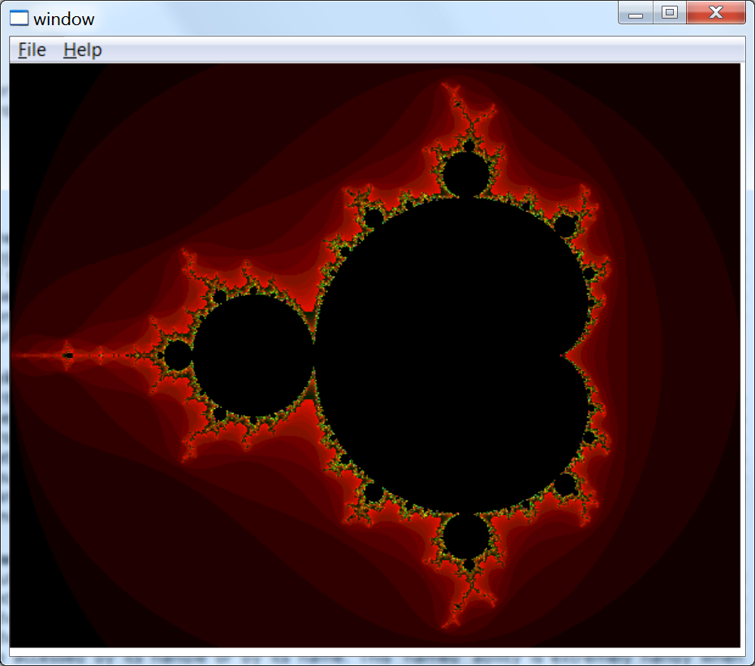
MandelBrot Set Pseudocolor Image
The project for Part II must be initially setup in VS as a WIN32 Application (GUI). VS generates hello world GUI code in myproject.cpp with a default window that can contain graphics (unlike the earlier text only WIN32 console application). A basic hello world window is around 4 pages of C++ code. This example could also be setup to run faster using multiple threads similar to part I, but with the limited time we have for this lab only one thread (i.e., the main program) will be used to keep it simple. A Windows application paints the color image in a WM_Paint case in the windows callback function (near the end of the myproject.cpp source code). It is called when the window first starts up and whenever an I/O event (mouse or keyboard action) occurs inside the window area. A Windows OS API, SetPixel, can be used to color individual pixels. So the Mandelbrot code needs to compute the pixel colors in the 2D array first, and then draw the color image in a 2D For loop with SetPixel calls. Something like the code below will need to be added inside the paint case in the windows callback function:
case WM_PAINT:
hdc = BeginPaint(hWnd, &ps);
// TODO: Add any drawing code here...
// Compute data for image pixel color array
Mandelbrot();
// now Paint the computed image in the Window
for(unsigned y=0; y<ImageHeight; ++y)
{
for(unsigned x=0; x<ImageWidth; ++x)
{
int color=Image[x][y];
//color each pixel using a pseudocolor based on the number of iterations
SetPixel(hdc, x, y, RGB((color & 0xF)*16,
((color >>4) &0xF)*16,((color >>8) & 0x0F)*16));
}
}
EndPaint(hWnd, &ps);EndPaint(hWnd, &ps);
break;

Note that the code above uses a function call to run the Mandelbrot calculations to fill the 2D array. Place the new variable declarations and the Mandelbrot function code (that you will need to add – the single thread code in part I based on code from the website at http://warp.povusers.org/Mandelbrot/), just before the callback function. It is a bit ugly to pass and return 2D arrays using functions in C++, so just make the 2D array a variable that is global and make the Image size a constant something like this from the earlier code:
//image size in pixels and image array setup
const unsigned ImageHeight=480;
const unsigned ImageWidth=600;
int Image[ImageWidth][ImageHeight];

Ideas for Further Work
Very complex images can be found on the boundaries of the Mandelbrot set. There are a lot of other interesting areas to explore in the Mandelbrot set and by changing the initial values of the complex constants, the program can plot them. Several are listed in table 1. With a bit more time and effort, it would be possible to add more features to allow the user to input or zoom into these areas using the keyboard or mouse. A new C++ complex class could also be used with operating overloading for complex numbers, but it would likely run just a bit slower and is probably overkill for this simple example with only one equation using complex variables. Global variables shared between threads that are both read and written must have a mutual exclusion lock using synchronization primitives for correct operation. Fortunately, these simple calculations do not need such variables. Code that reads or modifies shared global variables is called a critical section. There are also faster ways to draw images than SetPixel, but they are a bit complicated.
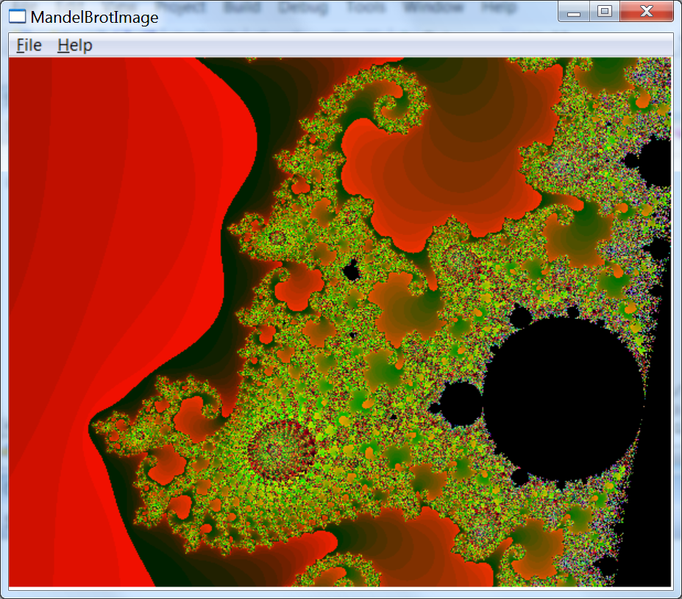
Mandelbrot set for MinRe = -0.75104, MaxRe = -0.7408, and MinIm = 0.10511.

Table 1: Other Interesting Areas to Examine
MinRe | MaxRe | MinIm
-0.19920 | -0.12954 | 1.10148
-0.95 | -0.88333 | 0.23333
-0.713 | -0.4082 | 0.49216
-1.781 | -1.764 | 0.0
-0.74758 | -0.74624 | 0.10671
-0.74591 | -0.74448 | 0.11196
-0.745538 | -0.745054 | 0.112881
-0.7454356 | -0.7454215 | 0.1130037
-0.7454301 | -0.7454289 | 0.1130076
The Windows OS offers several other synchronization primitives, sometimes called waitable objects. These are mutexes, semaphores, events, and critical sections. With the exception of the faster user mode critical section, the others are all kernel objects and each can be used to synchronize both processes and threads. The previous code example contained a semaphore. Semaphores can be used on both processes and threads.

Critical sections

Critical sections are user mode synchronization objects provided by the system. Because they operate in user mode, they are fast. Unfortunately, user-mode objects can't cross process boundaries, so critical sections won't work for synchronization tasks that run between different processes. Although critical sections can't be used across process boundaries, they are very useful for in-process synchronization needs and are able to handle most simple synchronization tasks. Critical sections are handy to protect data shared among threads.

Mutexes

Mutexes are kernel mode synchronization objects. As such, they are slower than critical sections because it takes time to switch from user mode to kernel mode, but they have the advantage that they can operate across process boundaries. Mutexes offer an additional advantage over Critical sections in that they can be 'named objects' whereby the mutex can be accessed by its handle or by its name. This 'named' ability is extremely handy when using the same mutex from different processes (and not threads only). An alternate to using a named mutex is to create the mutex in one process and then use the DuplicateHandle function to allow its use in another process. This approach can incur additional overhead because it requires the handle value and process id from the first process to be passed to the second process.

Events

Events are not really used to protect shared data per se, but are used to signal when an action has occurred. For example, if T1 changes some data, it is useful for T1 to signal T2 when the data has changed. Because of events' signaling ability, they are very useful. A common mistake with developers new to multithreaded programming is to use a 'time based' operation rather than event to wait. Use CreateEvent to initialize and SetEvent to signal an event. These events are frequently used with the WaitFor family of functions: WaitForSingleObject, WaitForMultipleObjects, and MsgWaitForMultipleObjects. Events are very important when performing multithreaded programming.
Table 1: MS Windows OS Critical Section, Mutex, and Semaphore Functions
Operation | Synchronization Object APIs
Operation | Critical Section | Mutex | Semaphore | Event
Initialize | InitializeCriticalSection | CreateMutex | CreateSemaphore | CreateEvent
Lock or Wait | EnterCriticalSection | WaitForSingleObject or WaitForMultipleObjects
Unlock or Signal | LeaveCriticalSection | ReleaseMutex | ReleaseSemaphore | SetEvent
Close | DeleteCriticalSection | CloseHandle

For more information on these APIs, their arguments, and example code, search using the function name in the VS on-line help or search for “synchronization functions”.

